## horizontal line

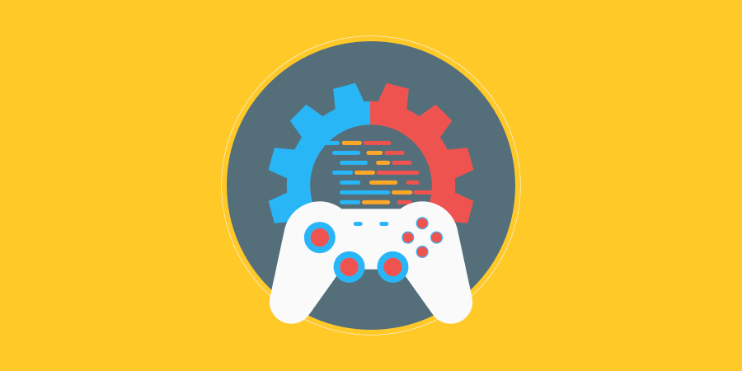

<AI Pathfinding>

XX.XX.20XX

**─**

Bobby Weeden

Your Student ID

# 

Task #1

## #1 List and describe the major AI terms used in the game industry.

* Deep Learning

This is an advanced version of machine learning, computers teach themselves with minimal programming by humans.

* Algorithm

An Algorithm is a formula or set of rules for performing a task. In AI, the algorithm tells the machine how to go about finding answers to a question or solutions to a problem.

* Machine Learning

Much like Deep Learning, this is when AI is focused on getting machines to act without being programmed to do so. Machines “learn” from patterns they recognize and adjust their behavior accordingly.

## #2 Describe what an algorithm is and how it can be applied in programming.

An Algorithm in AI can be simply described as a set of rules given to an AI program to allow it to learn what’s its dealing with on its own. Well-constructed algorithms can be the main factor in a good AI program and can determine how intelligent it actually is. An example of where algorithms can be used in general programming is when a website asks for a valid email address. The code is written in flow chart way that stores the email, checks if its a valid entry and gives a response back to the user based on the variable submitted.

## #3 Outline the difference between different pathfinding algorithms and compare their speed and complexity.

Dijkstra’s algorithm – Dijkstra's algorithm will want to try out every path and every vertex to find the shortest path between its starting point and destination, it is much slower than A* when searching for single destinations but performs well in finding multiple points and exploring all paths for low cost destination finding.

A* - This algorithm is optimized for calculating a single destination, and is

Dijkstra’s Algorithm can find paths to all locations; A* finds paths to one location. It prioritizes paths that seem to be leading closer to a goal.

## #4 Describe how object-oriented programming and inheritance could be used to create AI.

* Inheritance in AI scripts (car AI, gun ai) (animals)
* Funtional vs OOP